Camera MFD

Camera MFD is an MFD that sets a camera on any vessel, using D3D9 client.

Requirements

You need only to D3D9 client beta r980 or higher. The current stable version has a ‘wired-looking world’ bug when the MFD is used. You can get the latest build from [D3D9 development thread](https://www.orbiter-forum.com/showthread.php?goto=newpost&t=18431).

Installation

Just unpack the zip file in Orbiter root folder. It shouldn’t override any file in a base installation with D3D9 client.

After that, you need to enable custom cameras which Camera MFD uses. Open the launcher and choose ‘Video’ tab, and hit ‘Advanced’ button.

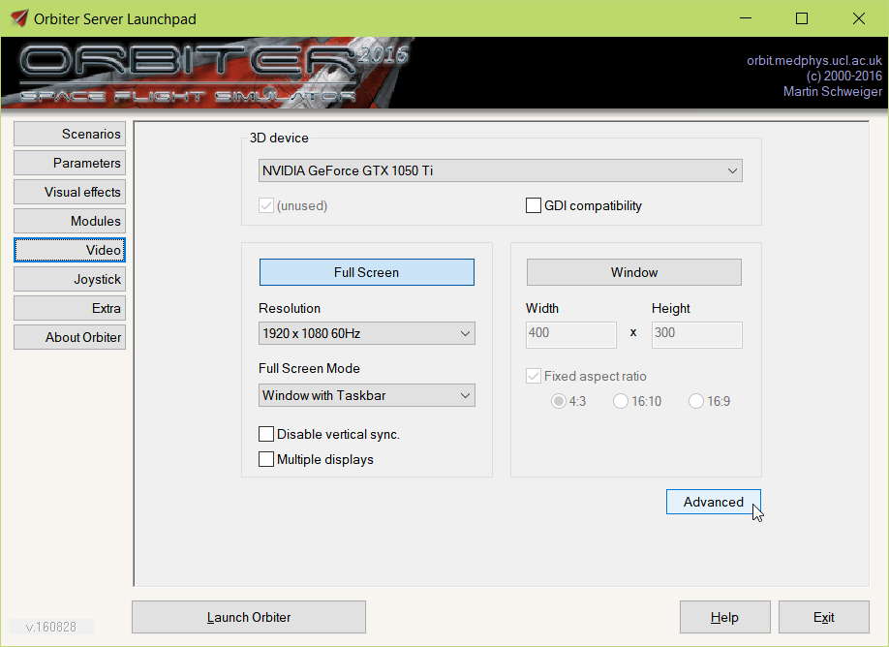

A settings window will appear. In ‘Reflections and Custom camera settings’ section, enable ‘Custom Cameras’ by selecting ‘Enabled’ in the list box.

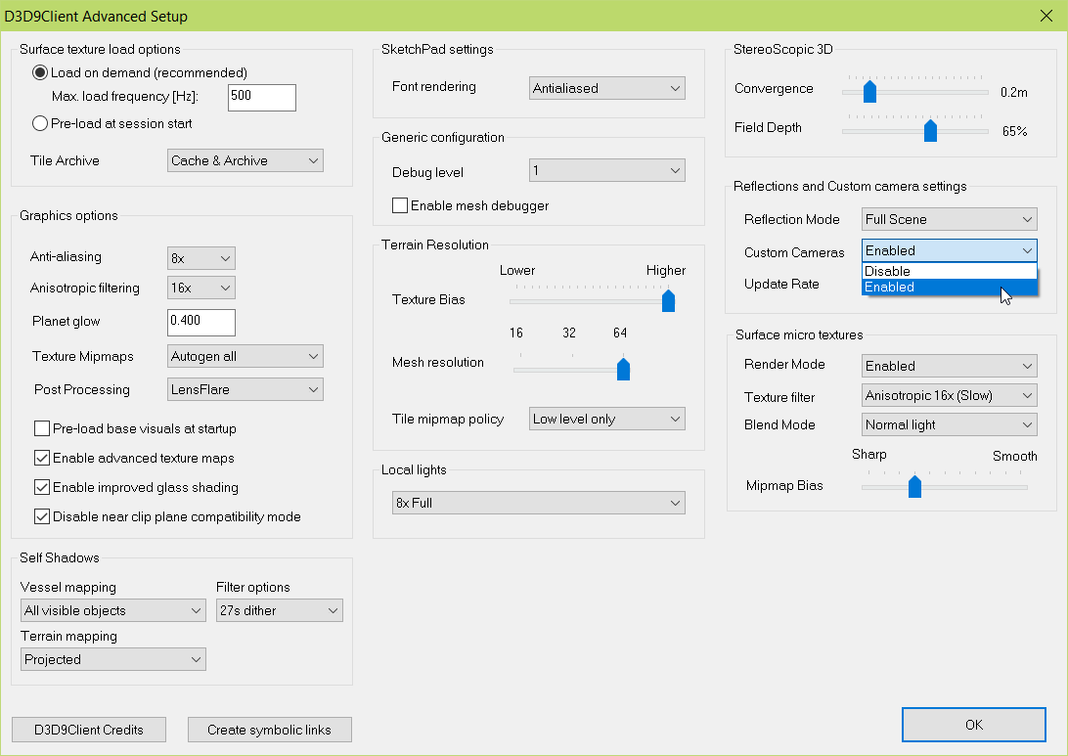

Then click on ‘Ok’ button to save the settings. Camera MFD should now work without any problems. Make sure to enable Camera MFD in ‘Modules’ tab, you can find it under MFD modes.

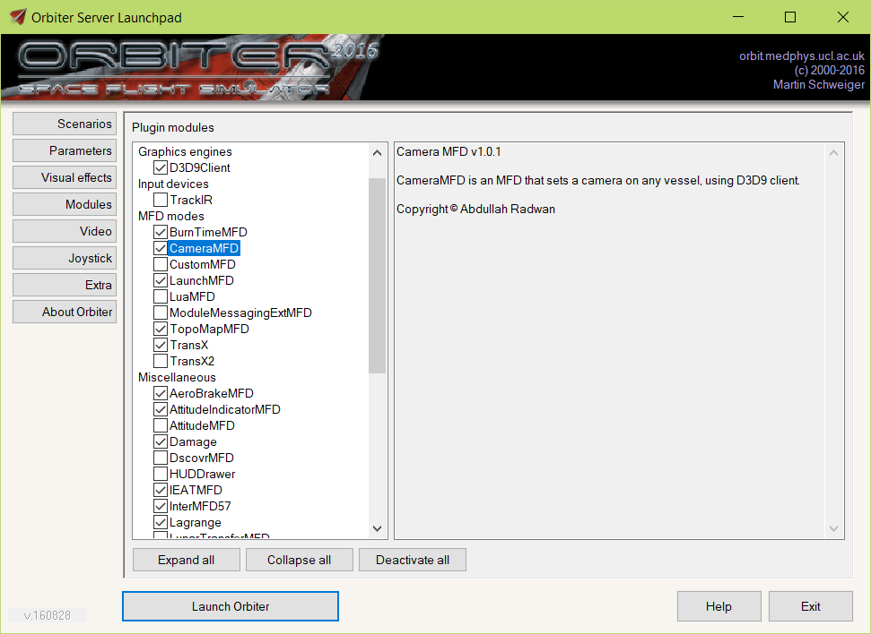

Usage

Select Camera MFD from the select menu and open it. The MFD will appear.

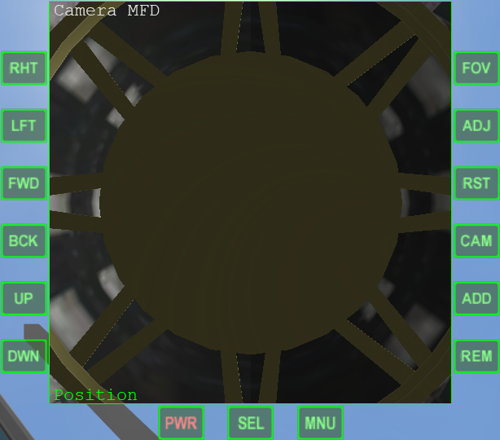

Try to move the camera using the left side buttons.

Below you can see the adjust mode. There are 3 adjust modes: Position, Direction, and Rotation.

Position mode will move the camera position as per the buttons. Direction mode will allow you to tilt the camera. Rotation mode will rotate the camera.

To adjust the zoom level, start clicking on ‘FOV’ button. This will change the field of view from 10 to 60 degrees, from the smaller to the bigger.

To change the adjust mode, click on ‘ADJ’ button. This will change the adjust mode between the 3 modes. ‘RST’ button will reset the current adjust mode to the default value.

Camera MFD supports multi-cameras. To add a new camera, hit ‘ADD’ button. This’ll create a new camera. You can move between cameras by clicking on ‘CAM’ button. To remove the current camera, hit ‘REM’ button.

Some ‘tricks’:

* To change the camera direction (Forward and backward), set the adjust mode to ‘Direction’ and use ‘UP’ and ‘DWN’ buttons.
* To rotate the camera 180 degrees, set the adjust mode to ‘Rotation’ and use FWD and BCK buttons.

About

The MFD is based on Orbiter 2016 API, D3D9 client, Visual Studio 2017 and C++. Any suggestions, bugs and contributes are welcomed. It’s open source under GPL 3 license. You can find the source in a [GitHub repository](https://github.com/abdullah-radwan/CameraMFD). Should you have any inquiries, don't hesitate to contact me on [abbodmar@gmail.com](mailto:abbodmar@gmail.com?subject=Camera%20MFD).

Copyright © Abdullah Radwan